IY4101 – Practical Programming

Object-Oriented Programming: Shape Management System
Abdul Raheem Kashif
Student ID: 303065799
Module: IY4101 Practical Programming
Assignment: Practical Programming Assignment 2
Submission Date: 1 April 2026
I confirm that this assignment is my own work.

Program Design
This program is designed using object-oriented programming principles to represent and manage a collection of geometric shapes. The aim of the system is to create a console-based Java application that allows different shapes to be stored, manipulated, and displayed while demonstrating the use of classes, inheritance, and method overriding.
The design centres around a superclass called Shape, which defines the common properties and behaviours shared by all shapes in the system. Each shape has a position on a two-dimensional coordinate plane and provides functionality for calculating its area, calculating its perimeter, translating its position, scaling its dimensions, and displaying its information. Rather than implementing this behaviour separately for every shape type, the shared structure is defined once in the Shape class and then reused by subclasses.
Four subclasses extend the Shape class: Rectangle, Square, Circle, and Triangle. Each subclass represents a specific geometric shape and provides its own implementation of the methods used to calculate area, perimeter, scaling behaviour, and display information. While the structure of each shape is inherited from the parent class, the mathematical calculations differ depending on the geometry of the shape. This approach reduces code duplication and allows the program to treat different shapes in a consistent way.
A separate Coordinates class is used to represent positions in two-dimensional space. Instead of storing x and y values directly in multiple classes, the program uses a dedicated class to manage coordinate data and related operations. This improves encapsulation because the coordinate logic is stored in one place, making the design easier to maintain and extend.
The program also includes a ShapeList class, which manages a collection of shapes. This class stores shapes inside an ArrayList<Shape> and provides operations such as adding shapes, removing shapes, retrieving shapes by position, translating shapes, scaling shapes, and displaying information about the stored shapes. Separating the list management from the shape classes helps keep responsibilities clearly organised.
Finally, the ShapeManagement class acts as the main controller of the application. This class contains the menu-driven interface that allows the user to interact with the system. Through the menu, the user can create shapes, remove shapes, display information about shapes, translate shapes, scale shapes, and exit the program. The class connects the user interface to the functionality provided by the ShapeList class.
Overall, the design separates the responsibilities of shape representation, coordinate management, list management, and user interaction. This modular structure makes the system easier to understand, test, and maintain. It also reflects key object-oriented programming concepts including encapsulation, inheritance, and polymorphism.

Class Structure
Coordinates Class
The Coordinates class represents a point in two-dimensional space using two integer values, x and y. It provides methods to retrieve the coordinate values, calculate the distance between two points, translate the point by a given amount, scale the coordinate values, and display the position as text.
This class is used by other classes to represent positions and vertices. By keeping coordinate-related functionality in one class, the program avoids repeating similar code in multiple places.

Shape Class
The Shape class acts as the superclass for all shapes in the system. It stores the position of the shape using a Coordinates object and defines common behaviour shared by all shapes.
The class includes methods for retrieving and setting coordinates, translating the shape, scaling the shape, calculating area, calculating perimeter, and displaying shape information. While the class defines these methods, the specific calculations for area and perimeter are implemented by the subclasses.

Rectangle Class
The Rectangle class extends the Shape class and represents a rectangle with a width and length. The constructor sets the position and dimensions of the rectangle.
The class overrides the methods for calculating area and perimeter, where the area is calculated using width × length and the perimeter is calculated using 2 × width + 2 × length. The scaling method adjusts the rectangle dimensions, and the display method outputs the rectangle information.

Square Class
The Square class also extends the Shape class. It represents a square with a single side length.
The area is calculated using side × side, and the perimeter is calculated using 4 × side. The scaling operation changes the side length, and the display method outputs the square’s details.

Circle Class
The Circle class represents a circle defined by a radius. The class extends the Shape class and overrides the required methods.
The area is calculated using the formula πr², and the perimeter (circumference) is calculated using 2πr. Scaling changes the radius value, and the display method outputs the circle’s information.
Triangle Class
The Triangle class extends the Shape class but differs slightly from the other shapes because it is defined using three vertices instead of a single dimension.
The triangle stores three coordinate objects representing its vertices. The perimeter is calculated by measuring the distances between the three points, and the area is calculated using Heron’s formula. Translation moves all three vertices by a specified distance, and scaling adjusts the triangle proportionally.

ShapeList Class
The ShapeList class manages a collection of shapes stored inside an ArrayList. It provides methods to add shapes, remove shapes, retrieve shapes by position, translate shapes, scale shapes, and display information about all stored shapes.
This class acts as the central data structure for the system and allows multiple shapes to be managed within a single program.

ShapeManagement Class
The ShapeManagement class is the entry point of the application. It provides the menu system that allows the user to interact with the program.
The menu allows the user to perform actions such as:
- adding shapes
- removing shapes
- retrieving information about a shape
- displaying all shapes
- translating shapes
- scaling shapes
- exiting the program
This class controls the program flow and connects the user interface with the functionality implemented in the other classes.

UML Class Diagram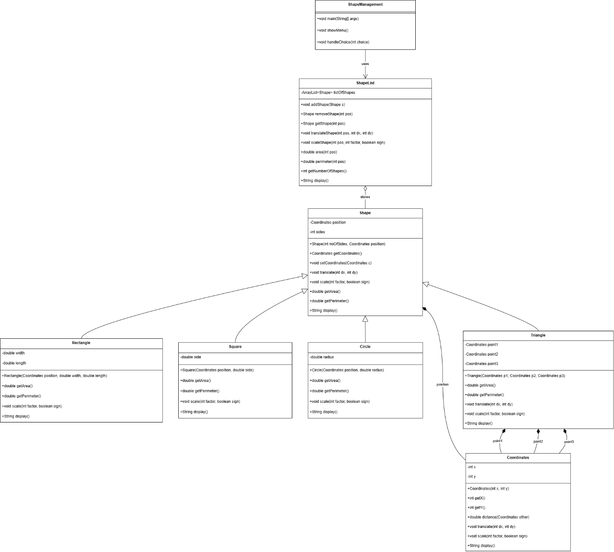
Figure 1: UML Class Diagram for the Shape Management System
This diagram illustrates the class structure of the program, showing the relationships between the main classes used in the system. The Shape class acts as the superclass, while Rectangle, Square, Circle, and Triangle inherit from it. The Coordinates class represents positional data for shapes, while ShapeList manages the collection of shapes stored in the program. The ShapeManagement class provides the menu-driven interface and controls the overall execution of the application.

